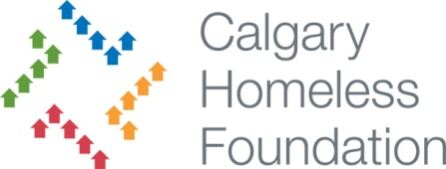**Calgary Homeless Foundation**

**Remediation Process**

**CHF Policy:** It is the CHF’s policy to work with an agency to remedy contract non-compliance and issues of performance first and foremost.

**Escalation Process:** Support from CHF notwithstanding, should the agency fail to rectify the contract non-compliance, CHF will follow an escalation process leading up to and possibly resulting in the termination of funding.

**Stages**

1. **Documentation**

Program Specialist will document any and all instances of contract non-compliance, or issues of performance as they occur, including any interaction with the agency in that regard. The Program Specialist will make a concerted effort to work with the agency to rectify these issues.

1. **Implementation of the Action Plan**

If contract non-compliance or issues of performance are ongoing, the P.S. will arrange an informal, fact finding meeting with the agency and a second CHF representative. CHF’s expectations and timelines will be made clear by way of an action plan template. Through the completion of the action plan, the agency will provide CHF with its intended process for sustained improvement. Diligent meeting minutes should be taken and sent to the agency, summarizing the content of the meeting.

1. **Monitoring of the Action Plan**

Over the course of the agreed upon timeframe, the Program Specialist will:

* Work to support the agency with the execution of the action plan
* Monitor for evidence of significant improvement
* Document observations

1. **First Official Letter of Remediation**

Despite the implementation of the action plan, if significant improvement has not been demonstrated by the agency within the agreed upon timeframe, a formal letter will be drafted and sent to the agency outlining the required amendments, expectations and potential consequences for the agency. In consultation with the Manager, Programs, agencies will determine an appropriate timeframe within which they must demonstrate sustained improvement. CHF will again offer to support the agency with achieving improvement.

1. **Final Official Letter of Remediation**

If sustained improvement has not been demonstrated by the agency, within the agreed upon timeframe, CHF will send a second and final letter stating that if the amendments are not completed within an agreed upon timeframe, CHF will be required to take one of the following actions:

* Reduce funding &/or Target Numbers
* Suspend funding until improvement has been demonstrated
* Cancel funding

1. **Execution of Remediation Action**

If improvements have once again not been demonstrated by the agency within the agreed upon timeframe, CHF will be required to carry out the aforementioned action, and report this outcome to the appropriate funder (HS or HPS).

1. **Follow up - Suspended Funding**

In cases where funding is suspended, CHF will provide the agency with a timeframe and a list of criteria that must be met, before funding can be reinstated.