Indicator #1: Fewer people experience homelessness
Understanding the data | 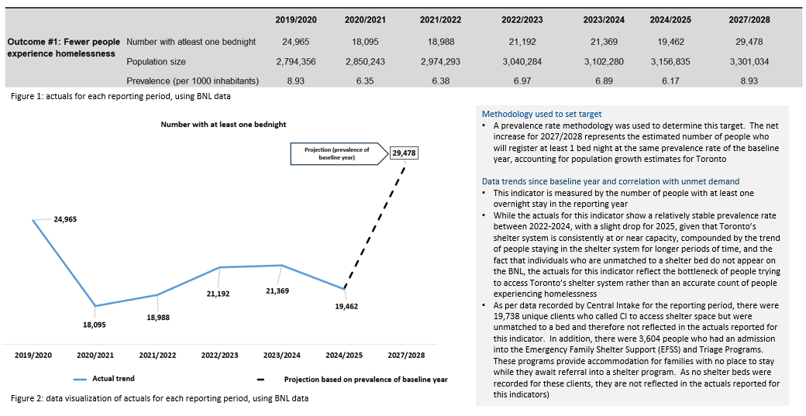
Context | Trends in Shelter Use: Inflows Vs Outflow and to access shelter space  - The actuals reflected in this indicator are directly related to the data reported for indicator #5 which measures chronic homelessness in the system. A year over year comparison of chronicity in the system confirms that in recent years people are less able to access overnight bedded program when they need it. For example, for the reporting year 2019/2020 only 32.8% were identified as experiencing chronic homelessness, however, in the current reporting year of 2024/2025 it has significantly increased to 63.2% (see graph below). Other data points, such as bed turn-over rates and unmatched Central Intake (CI) callers, validate this point .  - Increasing levels of chronicity are particularly acute in the family sector. In the current reporting year,84.6% of individuals staying in the family sector were experiencing chronic homelessness, representing a near doubling of 2022/2023 data, which was 43%. In the baseline year of 2019/2020 chronic homelessness was 37.5% among families. In the same baseline year, the system identified 8,720 families for this outcome #1. This number currently (N=4,661) is significantly lower than the baseline year and is due to the notable decrease in the rate of exit from the shelter system.  Street Needs Assessment Data: Homelessness is the result of failures across multiple systems  - There has been an overall increase in the number of people experiencing homelessness across all settings: City-administered shelters, people sleeping outdoors and in encampments, Violence Against Women Shelters, health and treatment facilities, and correctional facilities.  - The growing affordability gap is a key driver of the homelessness crisis. For example, while the maximum housing allowance for Ontario Works and Ontario Disability Support Program have increased by 4% and 22% respectively in the last 10 years, rents have increased by 62% over the same period  - The ongoing uncoordinated release of people from provincial institutions like health and correctional facilities without adequate housing plans in place contribute to the mounting occupancy pressures faced by Toronto’s shelter system. As well, limited response coordination at the provincial and national level pertaining to the large-scale arrival of refugee claimants has also compounded these pressure challenges.  Reducing the number of people experiencing homelessness  - The high volume of use for shelter services as reflected in this data is due to a number of factors, including insufficient supportive, rent-geared-to-income and affordable housing supply, a competitive and financialized housing market that diminishes attempts to increase affordable housing supply for low-income Torontonians, increased housing costs, a volatile economy with high inflation, wages and income supports that are too low to address the cost of living in Toronto  - The number of people entering the shelter system continues to substantially outpace the number of people moving out of the shelter system into permanent housing. Shelter System Flow Data for April 2024-March 2025 shows that 10,789 people entered the system (inflow), while 4,678 moved to permanent housing (outflow).  - Toronto’s shelter system has been operating at or near capacity for several years despite continuously expanding the system to better respond to service needs. The City will continue to mobilize solutions to address capacity demands including increasing the total number of new long-term and permanent spaces in the base shelter system by approximately 1,600 between 2024 and 2033 as well as continue to take strategic actions across the housing continuum to support a generational transformation of Toronto’s housing system. However, the City cannot act alone to address the complex challenges presented by a worsening homelessness crises and an everchanging housing market. In the absence of enhanced investments and collaborative planning among all orders of government, it is anticipated that there will not be a net reduction in this indicator. Maintaining the baseline prevalence rate is the most realistic target projected for this indicator

Indicator #2: New inflows into homelessness are reduced
Understanding the data | 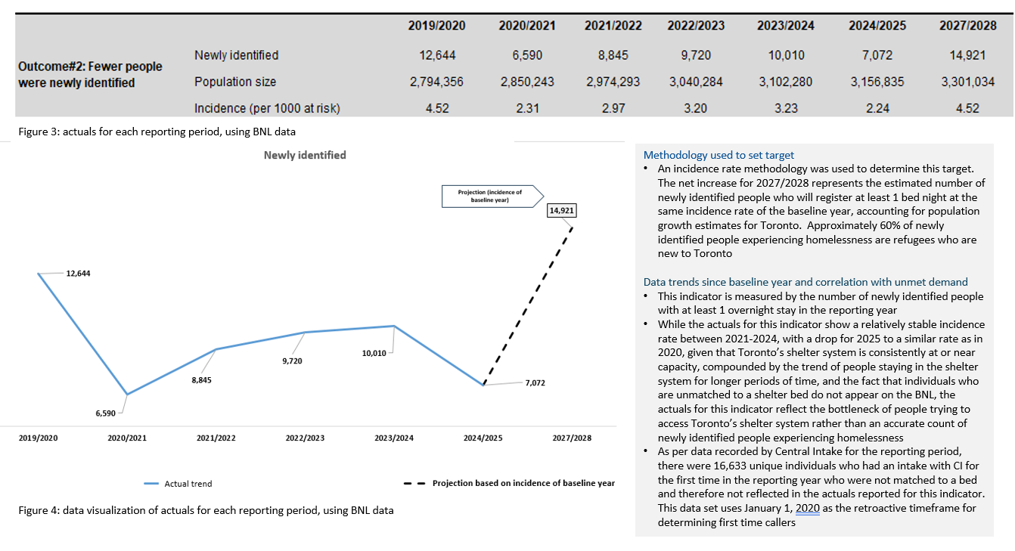
Context | Shelter trends related to new inflows  - International migration has been a key driver for this indicator.  - refugee claimants accounted for nearly 50% of all new inflows into homelessness in the current reporting year. While this is a reduction from the previous reporting year, refugee claimants constitute approximately 50% of total occupancy in the municipal shelter system.  - While refugee claimants have previously been more likely to exit the shelter system and move to permanent housing relatively quickly and less likely to return to homelessness, this has changed over time: 2022/2023 data shows that 43% of refugees were experiencing chronic homelessness, increasing to 56% in 2023/2024, and reaching 80% for the current reporting year.  - It is anticipated that this population group will continue to rely on emergency shelter services and will likely require those services for longer periods of time as Toronto's affordability crisis continues to deepen.  Street Needs Assessment Data: reasons for housing loss.  - Insufficient income and lack of affordable housing have consistently been key drivers of homelessness; however, the situation has worsened significantly over time. The leading cause of homelessness, reported by 41% of survey respondents, was inadequate income to afford housing, a proportion that has doubled since 2021.  - Among the top 4 supports that could have prevented homelessness, 3 are directly or indirectly related to income and/or financial assistance supports (e.g. 71% indicated that subsidized housing, 40% indicated that support to reach educational/employment goals, and 39% indicated that emergency financial assistance were key preventative factors)  - The second most cited support that could have prevented respondents’ homelessness was information/advice about renting and legal rights (42%)  Reducing the number of newly identified people experiencing homelessness  - Toronto is facing an evolving housing crisis, impacting housing affordability for low-income, vulnerable residents including people experiencing homelessness, and increasingly, key workers and middle-income earners as well.  - The City has taken significant action on housing, notably approving a whole-of-government response and range of strategic, program, and policy directions through the Advancing a Generational Transformation of Toronto's Housing System to Urgently Build More Affordable Homes strategy. City Council also increased the HousingTO 2020-2030 Action Plan (“HousingTO Plan") target to approve 65,000 rent-controlled homes (comprised of 6,500 rent-geared-to-income (RGI), 41,000 affordable rental and 17,500 rent-controlled market homes) by 2030.  - In the absence of enhanced investments and collaborative planning among all orders of government, it is anticipated that there will not be a net reduction in this indicator. Maintaining the baseline incidence rate is the most realistic target projected for this indicator

Indicator #3: Fewer people return to homelessness
Understanding the data | 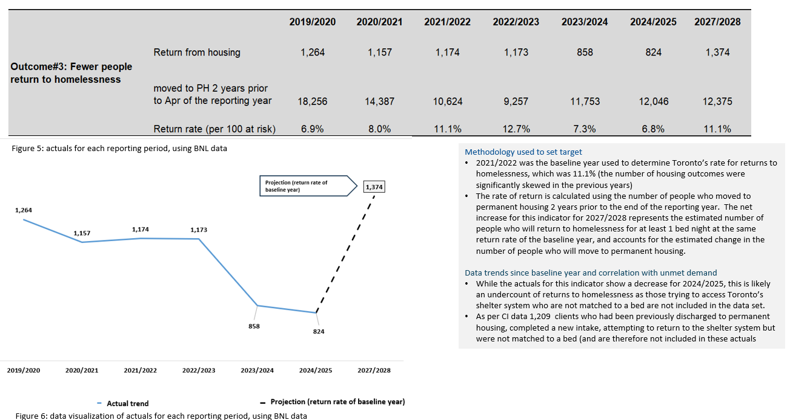
Context | Shelter trends related to returns to homelessness  - The bottleneck of demand for shelter services compared to availability of shelter space, as described in the context provided for indicator #1, directly impacts the data reported for returns to homelessness. Lack of system flow, limits who can access emergency shelter services, including those to were previously discharged to permanent housing and experience a new episode of homelessness  - At the same time, a preliminary literature review found that Toronto’s rate for returns to homelessness is lower than other municipalities in Canada and the US. A study from Montreal observed a return rate of 38% within a year among adult men after exiting shelter to housing. Other reviews related to re-entry into homelessness in a US context, reported higher return rates . This suggests that post-discharge housing stabilization investments are an effective intervention and require ongoing and increased investments to prevent housing loss.  Street Needs Assessment Data: housing loss  - Across all settings, inadequate income was the top reason for housing loss. This aligns with the solutions respondents identified as necessary to end their homelessness (income and other direct/indirect financial supports)  - 22% of respondents identified eviction as the cause of their most recent housing loss. This aligns with the second most cited support that could have prevented homelessness (information/advice about renting and legal rights)  Reducing returns to homelessness  - Considering current levels of funding, it is estimated that on average 5,500 people will continue to move to permanent housing every year (the current average number of yearly exits to permanent housing).  - In the absence of increased funding to support robust housing stabilization and eviction prevention interventions, as well as much needed and increased income supports, maintaining the baseline rate of return is projected for this indicator.

Indicator #4: Fewer Indigenous peoples experience homelessness
Understanding the data | 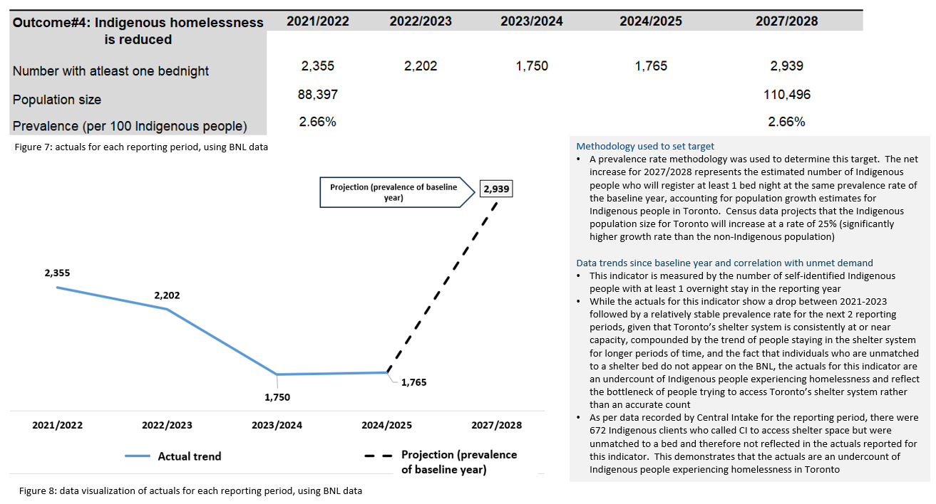
Context | Shelter trends related to Indigenous community members experiencing homelessness  - The bottleneck of demand for shelter services compared to availability of shelter space, as described in the context provided for indicator #1, directly impacts the data reported for Indigenous community members experiencing homelessness. Lack of system flow, limits who can access emergency shelter services, including Indigenous people needing service. As such, the data reported here is an undercount  - Additionally, Indigenous people are more likely to experience invisible homelessness and unsheltered homelessness, both of which are not included in this data set  Street Needs Assessment: Indigenous people are persistently over-represented among those experiencing homelessness  - Indigenous people represent up to 3.2% of Toronto’s population yet make up 9% of people experiencing homelessness, and 31% of people experiencing outdoor homelessness  - Indigenous respondents were also more likely to experience chronic homelessness compared to non-Indigenous respondents, and they continue to report higher rates of health challenges confirming that the direct and intergenerational impacts of the residential school system, and other colonial policies continue to contribute to poorer health and housing outcomes amongst Indigenous people  - More than half of Indigenous respondents reported having personal or family experience with the residential or industrial school system  Reducing the number of Indigenous community members experiencing homelessness  - Indigenous homelessness is understood as the direct result of ongoing colonization, structural/institutional racism, cultural genocide, and the impacts of intergenerational trauma.  - In the absence of increased funding, maintaining the baseline prevalence rate is projected for this indicator: addressing homelessness for Indigenous community members, requires increased investments in Indigenous-led solutions across all implicated systems (education, employment, housing, health care)  - The City has committed and will continue to dedicate resources to Indigenous-led solutions to prevent and address homelessness

Indicator #5: chronic homelessness is reduced
Understanding the data | 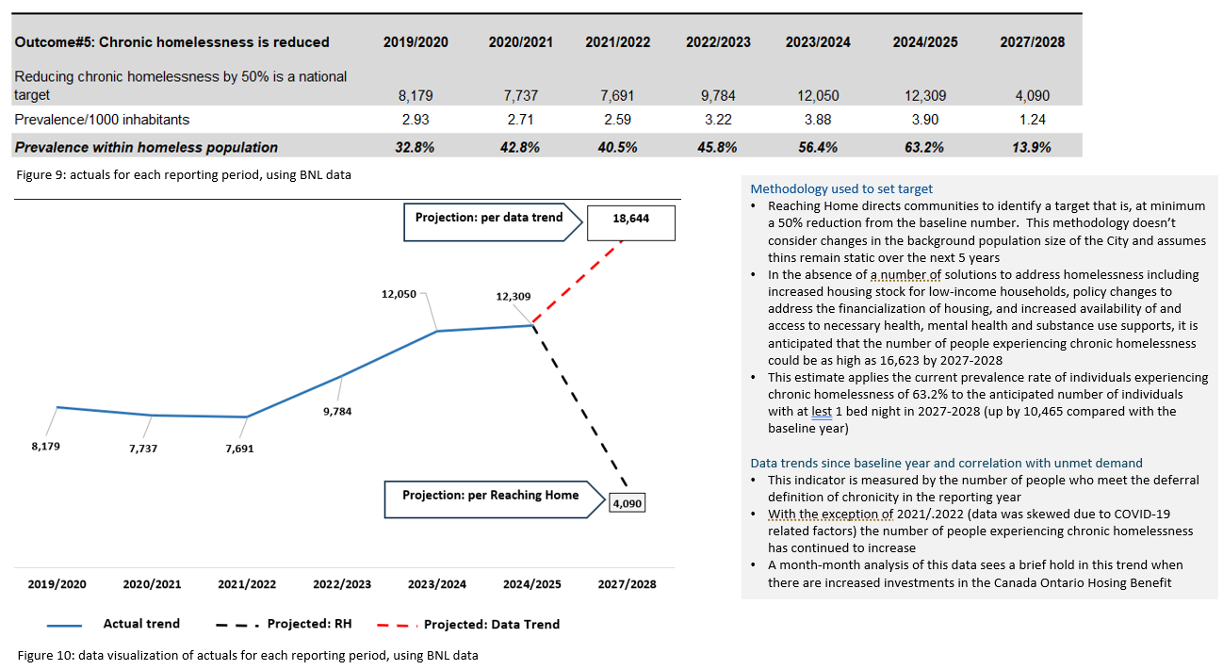
Context | Shelter trends, length of homelessness and chronicity  - Length of stay in the shelter system has increased across all population groups, including amongst refugee claimants who historically have had lower rates of chronic homelessness  - In order to achieve flow within the shelter system, the number of people exiting the shelter system each month to housing needs to outpace the number entering the system each month. The gap between the number of people who are becoming chronically homelessness compared with exits to permanent housing has been widening.  - Exits from the shelter system into permanent housing have also shifted over time, particularly since mid-2022, where almost all exits have been enabled through the support of a housing benefit, rent-geared-to-income housing, or housing opportunities available through Coordinated Access. In a housing affordability crisis, exiting homelessness in increasingly difficult without financial supports, directly resulting in longer shelter stays  Street Needs Assessment:  - 90% of people indicated they require multiple supports to help end their homelessness. These supports included having access to more affordable housing, monthly housing allowance, higher social assistance rates, help finding employment training, and help with their housing search  - Just under half of all respondents (49%) reported experiencing homelessness for at least 18 months in the past 3 years  - Respondents in correctional facilities (73%), outdoor (68%) and in health and treatment facilities (58%) and single adults in City-administered sites (51%) were most likely to experience chronic homelessness  Reducing the number of people experiencing chronic homelessness  - As set out in the HousingTO 2020-2030 Action Plan and the Homelessness Solutions Service Plan, by increasing available supportive and deeply affordable housing opportunities and reducing the length of time that people spend in shelter, existing shelter capacity will be freed up to be used for its originally intended purpose of short-term, emergency shelter  - Since 2023, the City has taken a number of unprecedented actions across the housing continuum to support a generational transformation of Toronto’s housing system: expansion of the HousingTO 2020-2030 Action Plan (HousingTO Plan) targets beyond affordable rental homes, to include RGI and rent-controlled homes; launch of the new Community Housing Pre-Development Fund, the Rental Housing Supply Program, and the new Toronto Builds Policy Framework; adoption of the Community Housing Growth and Modernization Strategy; and a limited expansion of financial incentives to community housing-led rent-controlled, market rental and ownership homes where they include affordable housing outcomes. Guided by the Housing Action Plan 2022-2026 (Housing Action Plan), City Council has also approved significant changes to the City’s Official Plan, zoning by-law, and development guidelines, to facilitate the growth of more housing types in diverse neighbourhoods.  - Despite increased action and investments, Toronto’s housing and homelessness crises have worsened. While the number of City-led and City-supported housing projects has grown, there is an increased need to focus resources on bringing these projects from initial financial approval to construction start and occupancy. Concerted action and investment from all orders of government and the private, health, and social services sectors is needed to respond to these crises.  - To support a generational transformation of Toronto’s housing system, the City is leveraging all available financial tools to advance the ambitious housing goals of the City, the province and the federal government. Federal and provincial investment in new purpose-built, affordable rental and supportive homes, mental health and social supports, higher social assistance rates and measures to protect tenants are proven to be most effective in complementing the City’s efforts to respond to the diverse needs of Toronto’s current and future residents.

Shelter System Requests for Referrals – City of Toronto
obm_duchesne_rothwell-reentry-study.pdf
Homelessness Service Outcomes and Reasons for Re-Entry - HPRI
OHC-Toronto-2021-Population-Estimates.pdf
Indigenous people of Toronto – City of Toronto
Toronto’s Population Health Profile: Insight on the health of our city

